Q1. Write a java program to check given number is positive or negative using if.

Enter Any Number : 5

This is Positive Number

Enter Any Number: -3

This is Negative Number

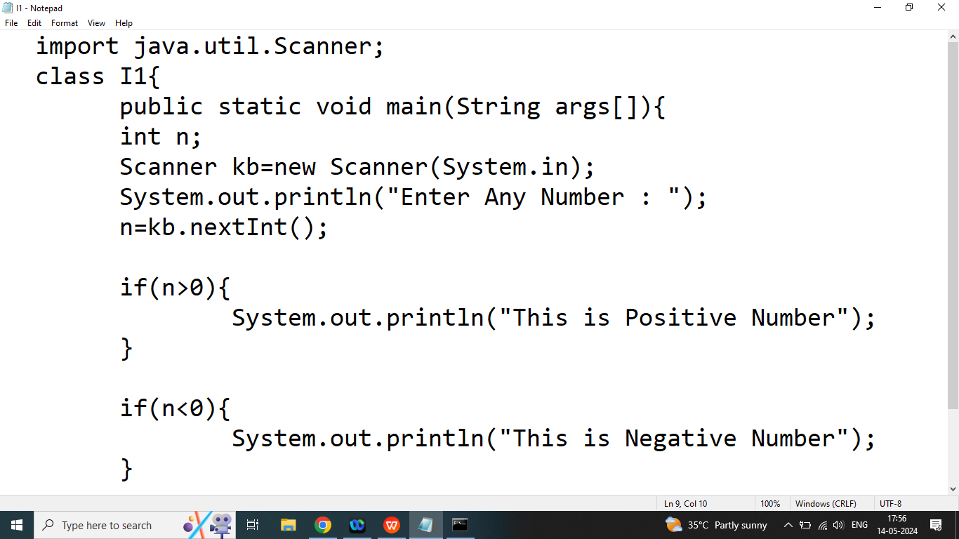

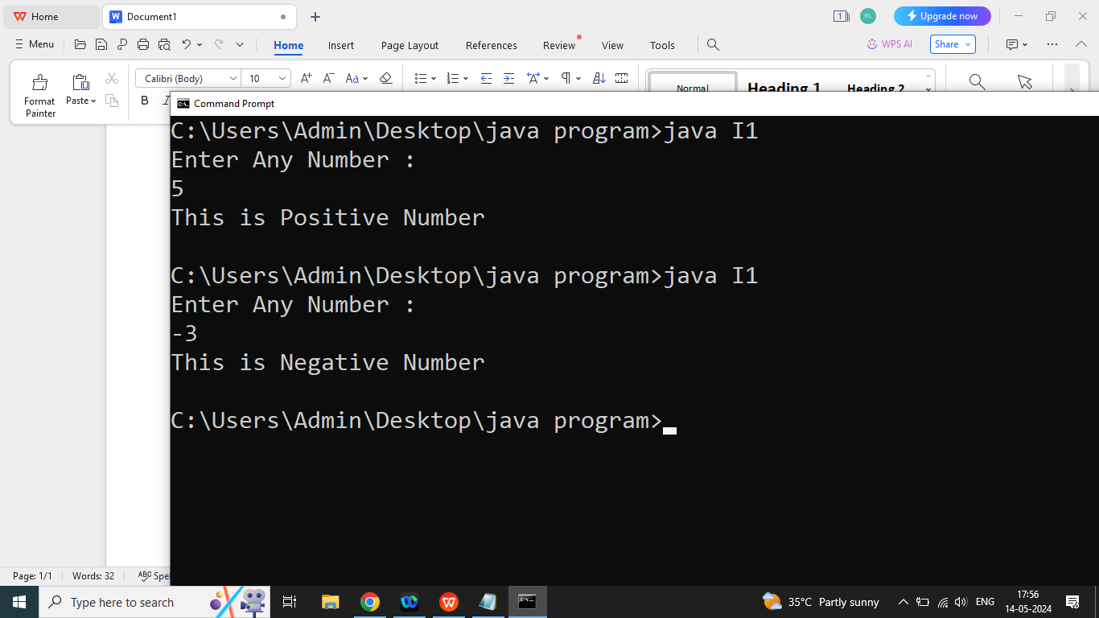

Q2. Explain if else statement in java programming?

Ans: if we have exactly two possibility then we should go for if else statement

The if else statement is used to execute both the true part and false part.

If given condition evaluated true statement of if will executed, if given condition evaluated false then statement of else will executed.

else always depends on if.

Syntax:

if(condition){

//if statement

}

else{

//else statement

}

Q2. Write a java program to check given number is even or odd using if else?

Enter Any Number : 46

Even Number

Enter Any Number: 47

Odd Number

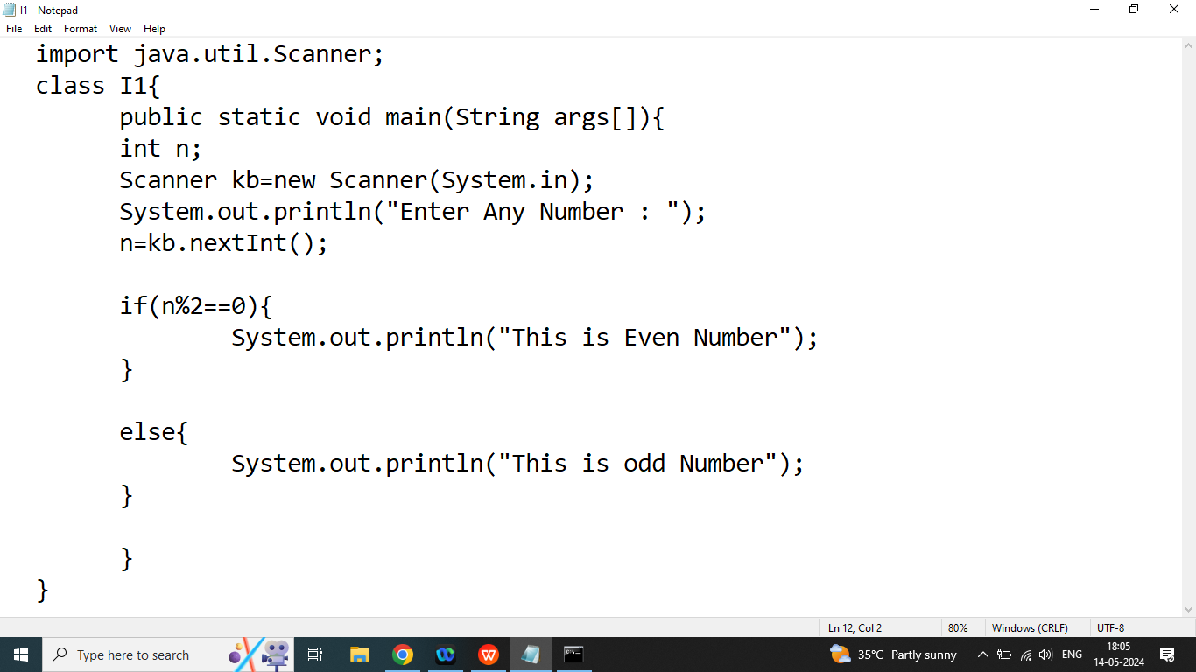

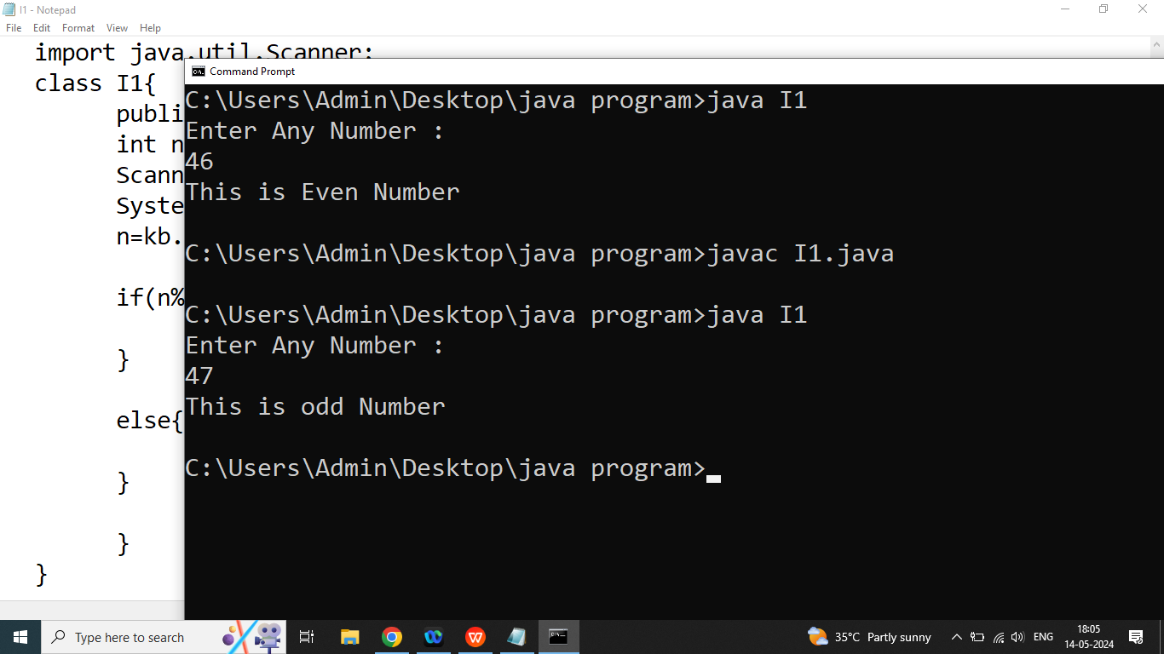

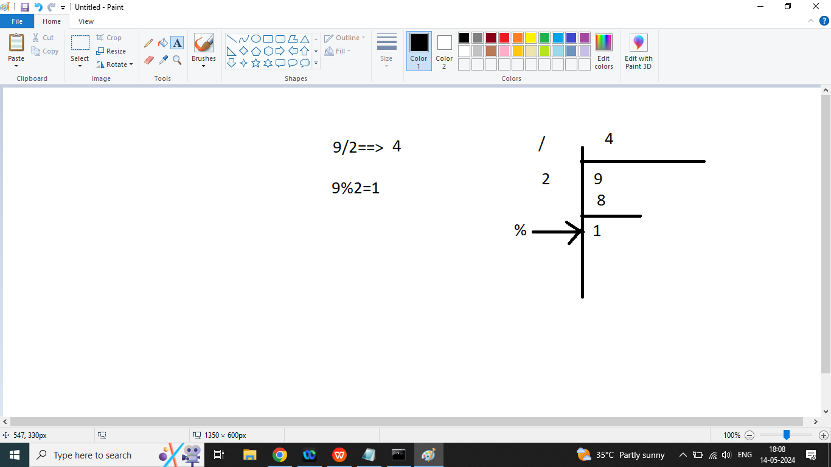

Q3. Explain else if statement in java programming?

Ans: if we have more than two possibilities and we want to execute only one at a time then we should go for else if statement

else if statement depends on if

Syntax:

if(condition1){

//statement 1

}

else if(condition2){

// statement 2

}

else if(condition 3){

//statement 3

}

else{

//statement 4

}

Q2. Write a java program to check given character is UpperCase, LowerCase, digits or special character

Enter Any Character: b

It is lowercase character

Enter Any Character: B

It is Upper Case Character

Enter Any character : 7

It is Digits

Enter Any character : %

It is special character

